**Software Testing Assignment**

**Module – 1**

1. **What is SDLC?**

A software development life cycle is essentially a series of steps or phase that provide a model for the development and life cycle management or piece of software.

1. **What is software testing?**

It is a activity where we check the actual requirement is equal to the expected requirement.

It makes the software defect free, bug free, and error free.

It checks any gap, missing requirements and error in contrary to the expected requirement.

1. **What is Agile methodology?**

It is a combination of iterative and incremental model.

It divides the software into small incremental builds, this build are provided in iteration, that means the big project are divided into small chunk (iterations).

Each iteration last about one to three weeks.

Each iteration involved all the team members working simultaneously on area like planning requirement analysis, design, coding unit testing and acceptance testing.

At the end of the iteration the working product is displayed to the customer or the important stake holder and it Is released in the market.

After the released we check for the feedback of the deployment software.

If any enhancement is needed in the project then it is done and its rereleased.

1. **What is SRS?**

A software requirement specification (SRS) is a complete description of the behavior of the system.

It includes a set of uses cases that describe all of the interactions that the user will have with the software.

Uses cases are also known as functional requirement, in addition to use cases, the SRS also contain Non -Functional (or supplementary) requirement.

1. **What is a OOPS (object oriented Programming)?**

Identifying object and assigning the responsibilities to these objects.

Objects communicates to other objects by any sending messages.

Messages are received by the method of an object.

An object is like a black box.

The internal details are hidden.

1. **Write Basic Concepts of OOPs?**

There are six basic concepts of OOP are as follows

1. Class
2. Object
3. Encapsulation
4. Inheritance
5. Polymorphism
6. Over ridding
7. Over loading
8. Abstraction
9. **What is object?**

Object gives the permission to access the functionality of class.

1. **What is class?**

Class is a collection of data and function

1. **What is Encapsulation?**

Wrapping the data

1. **What is Inheritance?**

Creating a class from an existing class.

1. **What is Polymorphism**?

One name multiple form

There are two type of Polymorphism

1. **Over ridding**

Function with same name and same parameter

1. **Over loading**

Function with same name and different parameter

1. **Draw use cases on Online Book Shopping?**

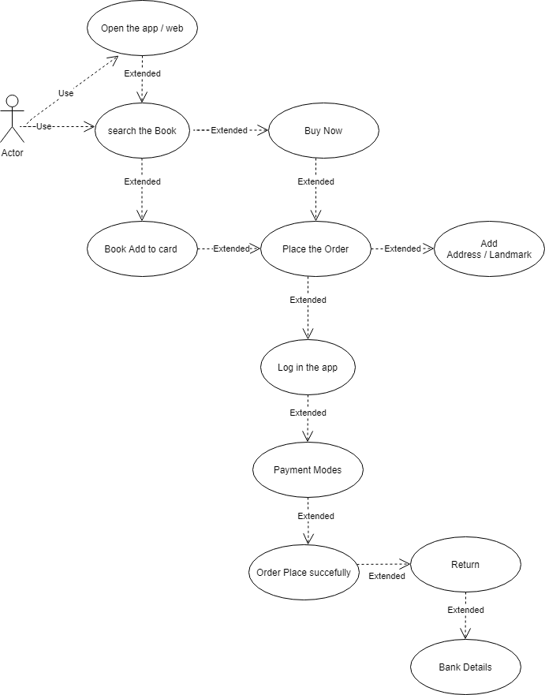

1. **Draw use cases on Online Bill Payment System (Payment)?**

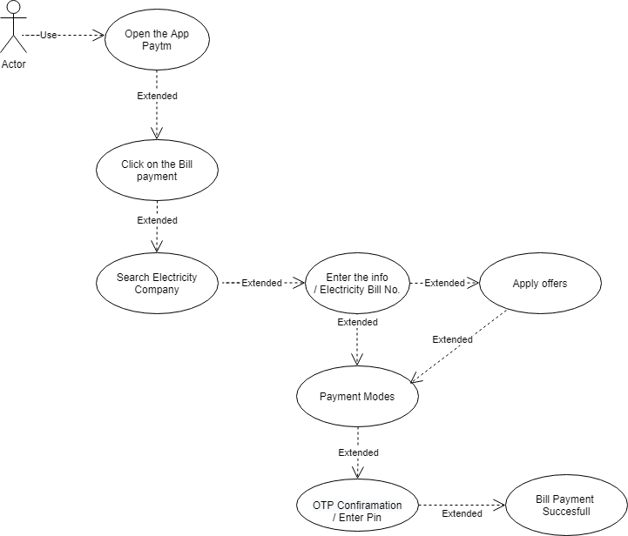

1. **Write SDLC phase with basic Introduction?**

There are six phases of SDLC

1. **Requirement collection / Gathering**

* Features
* Uses scenarios
* Although the requirement may be documented in written form, they may be incomplete, unambiguous or even incorrect
* Validation needed throughout the software life cycle , not only when the final system is delivered
* Functional requirement and nonfunctional requirement

1. **Analysis phase**

* Ideally this document states in a clear and precise fashion “what is to be built”
* This analysis represents the “WHAT” phase

1. **Design phase**

* Design architecture document
* Implementation plan
* Critical priority analysis
* Performance priority
* Test plan
* The design team can now expand upon the information establish in requirement document

1. **Implementation plan**

* In implementation phase , the team build the components either from scratch or by composition
* The implementation phase deals with issue of quality , performance baseline, libraries and debugging

1. **Testing phase**

* Simply states quality is very important. Many companies have not learned not quality is important and delivered more claimed functionality but at a lower quality level
* It is much easier to explain to a customer why there is a missing feature than to explain to a customer why the product lack quality
* A customer satisfied with the quality of a product will be remain loyal and wait for a new functionality in the next version

1. **Maintenance phase**

* **Maintenance is a process of changing a system after it has been deployed**

1. **Corrective maintenance**

Identifying and repairing defects

1. **Adaptive maintenance**

Adapting the existing solution to the new platforms

1. **Perfective maintenance**

Implementing the new requirements

1. **Explain phase of waterfall model**

The waterfall is unrealistic for many reasons especially

* Requirement must be “Frozen” to early in the life cycle
* Requirement are validated too late

There are two phase of water fall model

1. **Verification phase**
2. **Business requirement**

This is the first phase in the development cycle where the product requirement are understood from the customer perspective.

1. **System design (system requirement)**

Once you have the clear and detailed product requirement, its time o design the complete system.

1. **Architectural design (technical specification)**

Architectural specification are understood and design in this phase

1. **Module design ( program specification )**

In this phase the detailed internal design for all the system module is specified referred to as low level design (LLD)

1. **Code phase**

Actual coding is done in this phase

1. **Validation phase**
2. **Unit testing / module testing / component testing**

Unit test designed in the module design phase are executed on the code during this validation phase. Unit testing is the testing at code level and helps eliminating bugs at an early stage through all defects cannot be uncovered by unit testing

1. **Integration testing**

Integration testing is associated with the architectural design phase. Integration test are performed to test the co-existance and communication of the internal module within the system.

1. **System testing**

System testing is directly associated with the system design phase. System test checks the entire system functionality and the communication of the system under development with external system, most of the software and hardware compatibility issue can be uncovered during system test execution.

1. **Acceptance testing**

Acceptance testing is associated with the business requirement analysis phase and involves testing the product in user environment.

Acceptance test uncover the compatibility issue with the other system available in the user environment. It also discovered the non-functional issue such as load and performance defect in the actual user environment.

1. **Write phase of spiral model?**

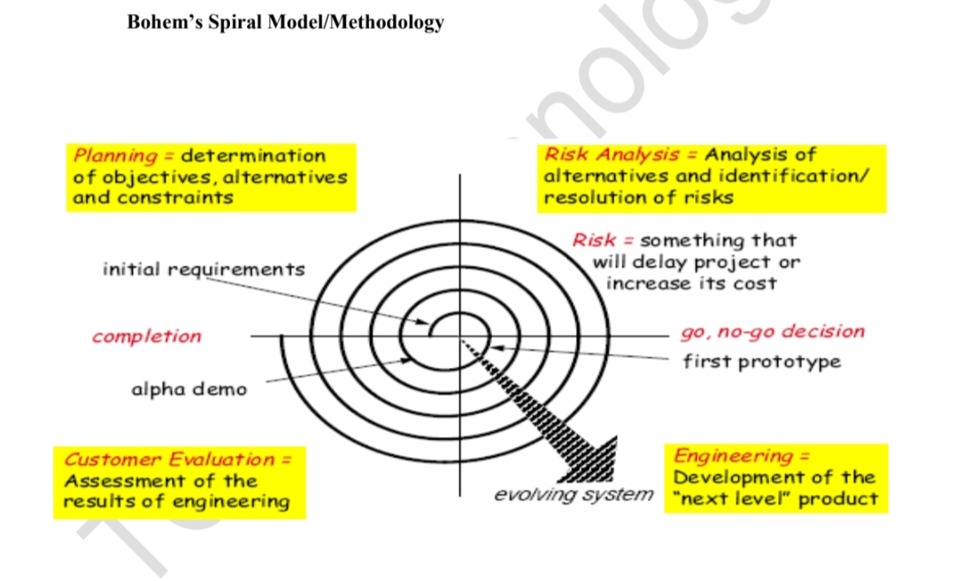

1. **Write Agile manifesto principles?**
2. Satisfy the customer through early and continuous delivery
3. Welcome changing requirement even late in the project
4. Deliver value frequently
5. Break the silos of your project
6. Build project around motivated individual
7. The most effective way of communication is face to face
8. Working software is the primary measure of progress
9. Maintain a sustainability working pace
10. Continuous excellence enhance agility
11. Simplicity is essential
12. Self-organizing team generate most value
13. Regularly reflect and adjust your way of work to boost effectiveness
14. **Explain working methodology of agile model and also write pros and cons**

**What is Agile methodology**

It is a combination of iterative and incremental model.

It divides the software into small incremental builds, this build are provided in iteration, that means the big project are divided into small chunk (iterations).

Each iteration last about one to three weeks.

Each iteration involved all the team members working simultaneously on area like planning requirement analysis, design, coding unit testing and acceptance testing.

At the end of the iteration the working product is displayed to the customer or the important stake holder and it Is released in the market.

After the released we check for the feedback of the deployment software.

If any enhancement is needed in the project then it is done and its rereleased.

1. **Pros**

* Frequent delivery
* Face to face communication with the customer
* Less time
* Adaptability

1. **Cons**

* Less documentation
* Maintenance problem

1. **Draw use case on Online shopping product using COD**

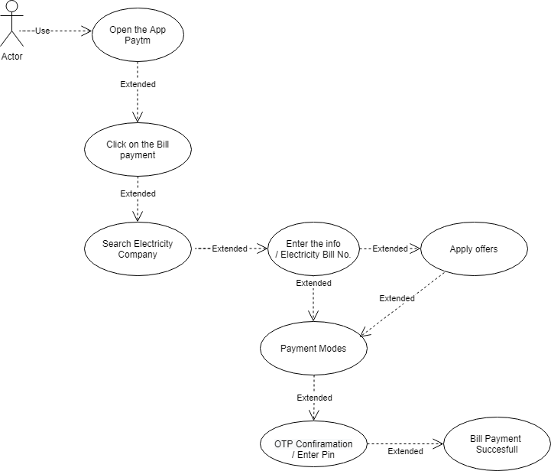

1. **Draw use case on Online shopping product using payment gateway**

